Output of Implement the component labeling algorithm

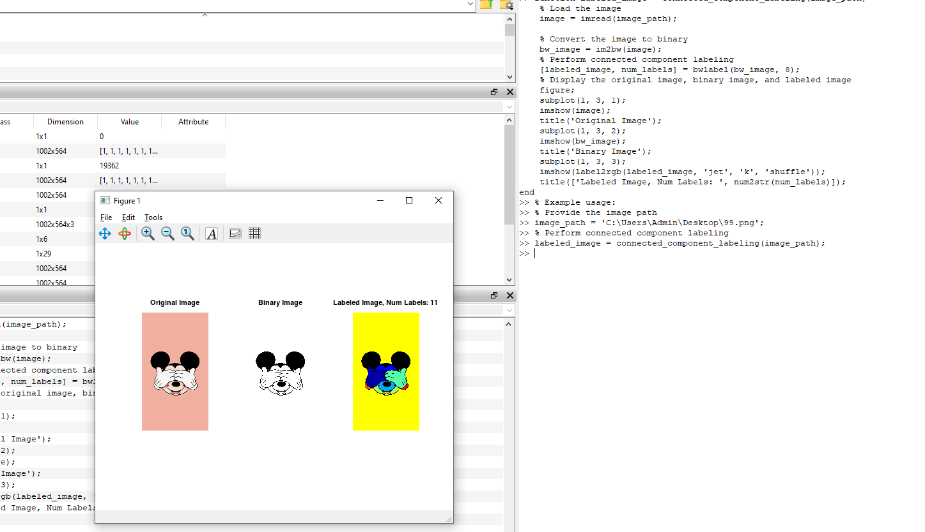

&Modify the component labeling algorithm from task 1 to consider the 8- connectivity.

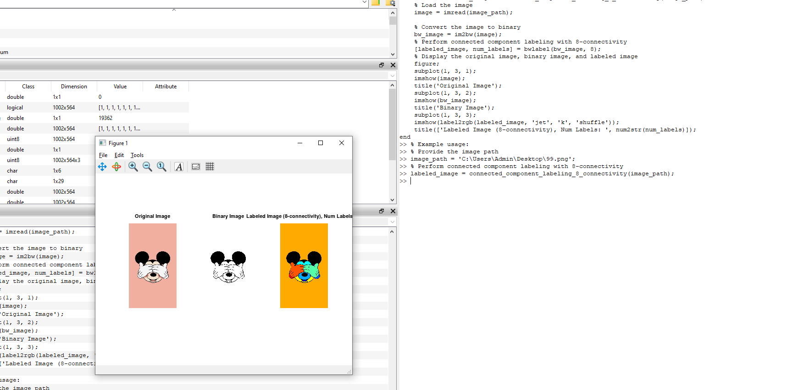

Output Modify the component labeling algorithm from task 1 to consider a range of intensity values within the set V, where V={min-max}, to determine pixel connectivity. The values of min and max are user-input parameters

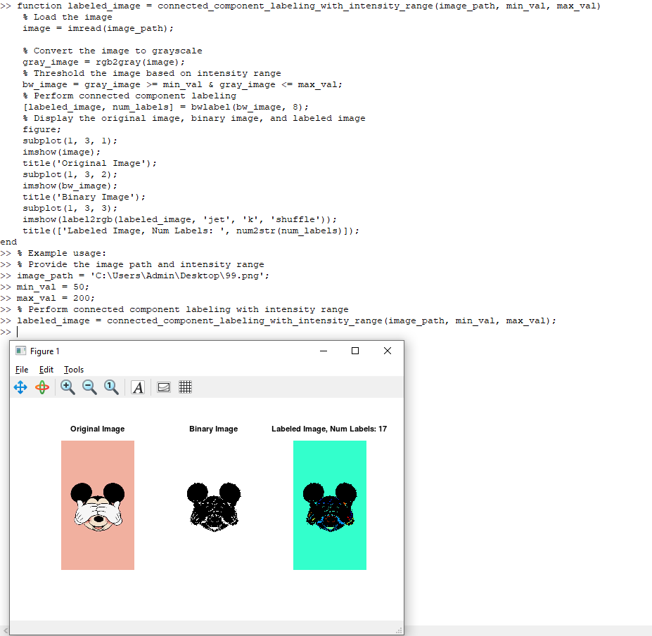

Implement the size filter algorithm

